­



Politecnico di Milano

A.A. 2015-2016

Software Engineering 2: “MyTaxi”

Project Reporting

Manzi Giuseppe (mat. 854470) &

Nicolini Alessandro (mat. 858858)

CONTENTS

1. Introduction 4

1.1 Purpose 4

1.2 Definitions 4

2. Functional Point 4

2.1 Introduction 4

2.2 Internal Logic Files (ILF) 5

2.3 External Interface File (EIF) 5

2.4 External Inputs 5

2.5 External Output: 5

2.6 External Inquiries: 6

3. COCOMO approach 8

4. Allocated Resources 9

4.1 Allocated Resources for Analysis and Planning 9

4.2 Allocated resources for “Implementation and Testing” 10

5. Schedule 11

6. Risk 12

# 1. Introduction

## 1.1 Purpose

The aim of this document is to give an estimation of the cost of the project in terms of money, time, resources and effort. We will use the COCOMO approach to compute the possible cost and effort and we will give a schedule showing how the resources should be (or has been) allocated for the different tasks during the project development time.

## 1.2 Definitions

*Analysis and Planning phase:* the phase of the project development before the beginning of implementation, including Requirement analysis, Design and Architecture analysis, Test planning and Project Reporting.

*Implementation phase:* the phase of the project development starting at the begin of implementation, including Implementation, Testing and Deployment.

**Note:** Actually there is not a properly defined time limit between the end of a phase and the beginning of the other one, since we adopted the spiral model for the development process. However, we decided to remark this distinction to have two different terms to identify the already done work and the work to do.

# 2. Functional Point

## 2.1 Introduction

Calculated in the first phases of the development process, Functional Point is a way to estimate the effort to develop a software product depends on the RASD functionalities of our “MyTaxy”.

The functionalities has been groped in:

* **Internal Logical File (ILF):** homogeneous set of data used and managed by our application (User or Past Request File in the DataBase)
* **External Interface File (EIF):** data used by our application but generated and maintained by other applications, in our project Google Maps and SMS
* **External Input:** elementary operation to elaborate data coming form the external environment such as login, insert user, position, request and reservation
* **External Output**: elementary operation that generates data for the external environment, it usually includes the elaboration of data from logic files such as Notification, request detail ecc
* **External Inquiry:** Elementary operation that involves input and output without significant elaboration of data from logic files

The following table outline the number of Functional Point based on funtionality

and relative complexity:



## 2.2 Internal Logic Files (ILF)

The application included in ILF store the information:

* Users (simple structure)
* PastRequests (simple structure)

The total amount of FPs is 14 = 7 + 7.

## 2.3 External Interface File (EIF)

For the interaction Api are:

* SMS sending (simple interface)
* Google Maps (Medium interface)

The total amount of FPs is 5 + 7 = **12**.

## 2.4 External Inputs

The application interacts with the user:

* Login/logout (simple input)
* Sign up (simple input)
* Position (simple input)
* Create Request (simple input)
* Create Reservation (medium input)
* Modify Reservation (medium input)
* Delete Reservation (medium input)
* Set Taxi driver state (simple input)
* Confirm Costumer’s presence (simple input)
* Decline a ride (simple input)

The total amount of FPs is 3+3+3+3+4+4+4+3+3+3 = **33**.

## 2.5 External Output:

* Notification of Request for users and taxi (medium output)
* Notification of Reservation (medium output)
* Notification of changing zone (high output)

The total amount of FPs is 5+5+7 = **17.**

## 2.6 External Inquiries:

* Information Recap in PRA (medium operation)

The total amount of FPs is **4**

Detailed computation using excel:



**TOTAL = 80 FPs**

This value can be used as a basis to estimate the size of the project in KLOC and

then use another approach such as COCOMO to estimate the effort.

# 3. COCOMO approach

To pass from FP to SLOC we use an average conversion factor of 46 as we see in the table described at http://www.qsm.com/resources/function-point-languages-table, an updated

version that adds J2EE of the table included in official manual.

$80 FPs*46=3680 SLOC$

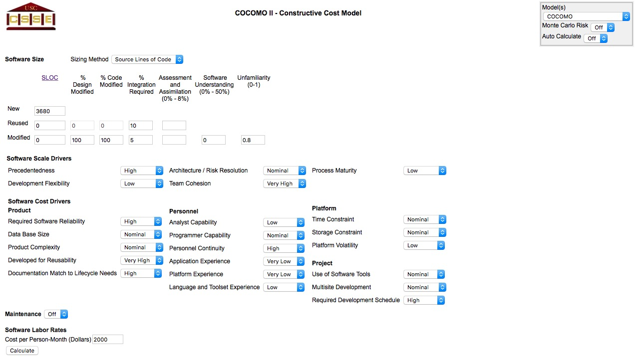

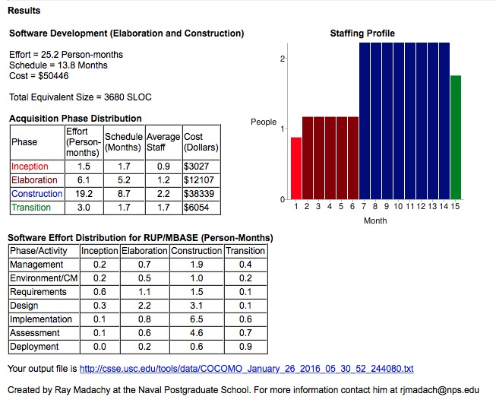

Obviously the estimation given by COCOMO doesn’t respect the real effort we did during these months. In fact, COCOMO estimate real project and not academic ones. So there is a big difference between the COCOMO estimated effort and the real effort we did.

# 4. Allocated Resources

## 4.1 Allocated Resources for Analysis and Planning

Here there is the total amount of hour for all the assignment of our project:

* Requirements Analysis and Specifications Document:
  + Giuseppe Manzi: 40 hours
  + Alessandro Nicolini: 40 hours
* Design Document
  + Giuseppe Manzi: 30 hours
  + Alessandro Nicolini: 30 hours
* Inspection and Test Plan Document:
  + Giuseppe Manzi: 9 hours
  + Alessandro Nicolini: 9 hours
* Project Reporting:
  + Giuseppe Manzi: 10 hours
  + Alessandro Nicolini: 10 hours

The total hours of work during “Analisys and Planning” phases of the project are 178 hours.

*178 hours / (40*4) hours = 1,12 Person-Months*

Under the assumption that one person can work 40 hours per week.

## 4.2 Allocated resources for “Implementation and Testing”

We provide two different estimations for the remaining effort due to the consideration given at the end of the 3rd paragraph.

* COCOMO approach computed an estimated effort of 25.2 Person-month. The Analysis and Planning part of the Development process took 178 hours. So, assuming that a person can work 40 hours a week, we can calculate the estimated effort for the rest of the Development process:

$${effort}_{r}=\frac{(25.2*40*4-178)}{40*4}=24,1 person–months$$

Supposing that we want to complete the development before the 15th of July, the implementation and testing phases should be assigned to a team composed by 5 people.

* Summing the effort coefficient of the distribution table obtained using COCOMO, we have:

$$\sum_{i∈Phases, j∈Activities}{c_{i,j}}≈15,7$$

Supposing that we want to complete the development before the 15th of July, the implementation and testing phases should be assigned to a team composed by 3 people.

# 5. Schedule

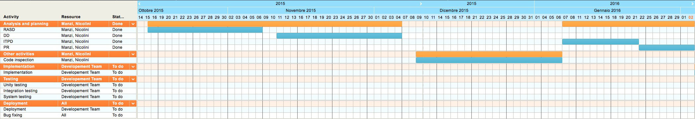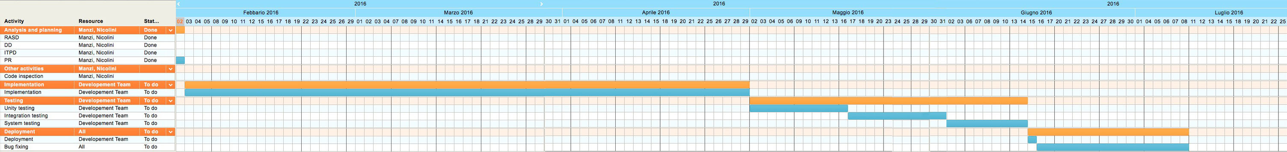

From 02/02/2016

Till 02/02/2016

# 6. Risk

Define the risks for the Project their Relevance and The associated Recovery actions

The potential problem of our project could be caused by risk in Concerning future happenings, change of opinion or action and the choice choose.

Kind of Risks:

|  |  |  |
| --- | --- | --- |
| Risk | Effect | Recovery |
| Organization problem cause problem in project budget | Low | More money or cut salary |
| Illness of Personal | Moderate | More time |
| Impossible recruit staff / loss of personal | Moderate | Find new person (less qualified)/ More time |
| Unsuitable Structures | High | More time + more money/  lower standard |
| Different Manager points of view during the analysis | Low | More Time |
| Stakeholder change choice | High | Change project + More Time |